Project Proposal and Timelines

Date- 14/8/24

**Proposed Title-** AI BASED DESIGN FOR FREQUENCY SELECTIVE SURFACE(FSS)

**Objectives**-

* **Develop a Fully-Connected Regression Model (FCRM) utilizing Bayesian Optimization (BO) for automated DNN architecture and hyperparameter selection.**
* **Optimize DNN-Based Surrogates by using BO to systematically improve the design and parameters of models for frequency selective surfaces (FSSs).**
* **Enhance Prediction Accuracy and reduce sensitivity to training data by applying the FCRM framework.**
* **Validate the Methodology through modeling a Minkowski Fractal-Based FSS and comparing its performance with traditional and conventional models.**

**Introduction:**

In the rapidly evolving field of electromagnetic engineering, Frequency Selective Surfaces (FSS) have emerged as a crucial component in applications ranging from radar systems to satellite communications. These surfaces, characterized by their ability to selectively filter electromagnetic waves, play a pivotal role in controlling signal propagation. Traditionally, the design and optimization of FSS have relied on empirical methods and iterative simulations, which are often time-consuming and computationally expensive.

This project explores the integration of Artificial Intelligence (AI) into the design process of FSS, aiming to enhance efficiency, accuracy, and adaptability. By leveraging advanced machine learning algorithms, our approach seeks to automate the optimization of FSS parameters, enabling rapid prototyping and exploration of complex design spaces. This AI-based methodology not only reduces the design cycle time but also opens new possibilities for creating innovative FSS structures with tailored electromagnetic properties.

Through this project, we aim to demonstrate the potential of AI in revolutionizing the design process of Frequency Selective Surfaces, making it more accessible and scalable for various high-frequency applications.

**Problem Statement:**

The problem addressed in this project is the challenge of efficiently and accurately modeling the highly nonlinear behavior of microwave passive components, such as Frequency Selective Surfaces (FSSs), over broad frequency ranges. Traditional methods for selecting the architecture and hyperparameters of deep neural network (DNN) models rely heavily on trial and error, leading to suboptimal models with poor generalization and high variance. The need exists for a more systematic and automated approach to optimize DNN-based surrogate models for these complex structures.

Methodology:

1. SURROGATE MODELING USING DEEP NEURAL NETWORKS.DEEP LEARNING AND ITS CHALLENGES

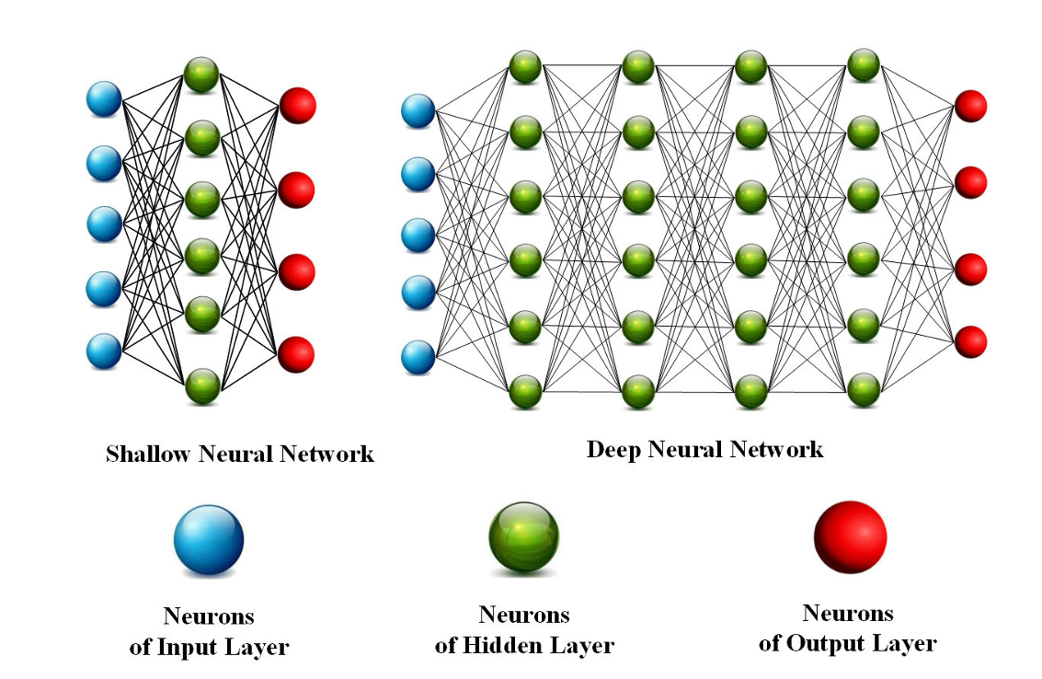

The design of microwave components like Frequency Selective Surfaces (FSS) is hindered by time-consuming simulations and the limitations of shallow neural network models, which struggle to capture complex nonlinear dependencies. Deep Neural Networks (DNNs) offer a more powerful alternative but are challenging to train due to the lack of universal hyperparameter selection methods. This project aims to develop an automated training procedure for DNN-based surrogate models to improve the efficiency and accuracy of FSS design, ultimately enabling quicker and more precise optimization of these components.

1. PROPOSED TECHNIQUE: FULLY-CONNECTED REGRESSION MODEL(FCRM)

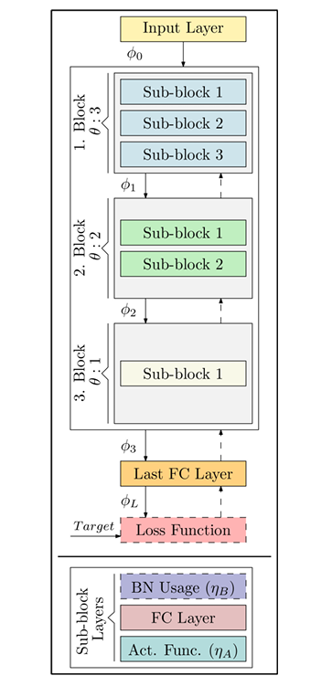

It proposes a Fully-Connected Regression Model (FCRM) for the efficient training of Deep Neural Networks (DNNs) in microwave design, particularly for Frequency Selective Surfaces (FSS). The FCRM utilizes Bayesian Optimization to automatically determine the model's architecture, including the number of neurons, layers, and activation functions like ReLU and Leaky ReLU. The model addresses common challenges in DNN training, such as vanishing gradients and internal covariate shift, through techniques like Batch Normalization (BN). This approach allows the FCRM to adapt and evolve automatically based on input data, minimizing the need for manual adjustments.

1. FCRM SETUP VIA BAYESIAN OPTIMIZATION

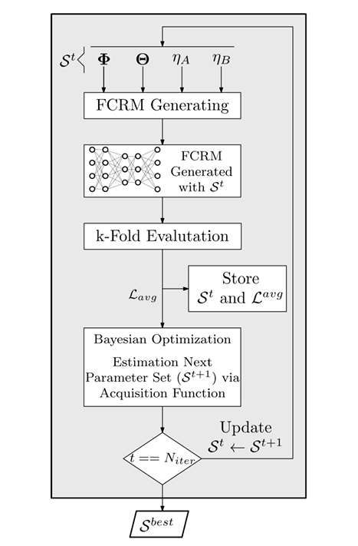

The importance of selecting appropriate hyperparameters for ANN-based models to improve performance in classification or regression tasks. Bayesian Optimization (BO) is proposed for efficient model training, leveraging probabilistic modeling to globally optimize complex functions. BO employs Gaussian Processes (GP) to iteratively refine the model's architecture, including the number of layers, neurons, and activation functions. The process balances exploration and exploitation to find the optimal parameters, reducing computational expenses. The algorithm's operation for FCRM model training is detailed, emphasizing its adaptability and potential for broader applications.

1. MODELING FRAMEWORK

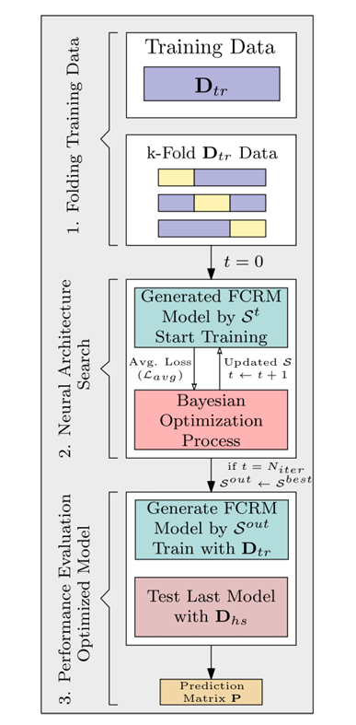

The overall modeling procedure using the Fully-Connected Regression Model (FCRM) surrogate, depicted in a flow diagram. The process begins with acquiring training and hold-out datasets. The model is constructed based on a user-defined number of blocks, with Bayesian Optimization (BO) iteratively refining the model by adjusting hyperparameters to minimize the loss over k-fold cross-validation. Once the optimization process is complete, the best hyperparameter set is used to construct the final FCRM model, which is then trained on the entire dataset and validated using the hold-out data.

Timeline:-

|  |  |
| --- | --- |
| Timelines | Outcomes/Goals |
| Review 1 |  |
| Review 2 |  |
| End Sem  Final Review |  |

Names of the students with Roll Number:-

EC21B1044- SANAPALA CHANDRA SEKHAR

EC21B1043- SADHU POORNA SAI

EC21B1023- KAPA ADHEESHWAR REDDY

Name and Signature of the Guide